**Chapter 1: Introduction to Project**

**1.1 Introduction to Project**

In the era of sustainable living and conscious consumerism, the demand for plant-based products has witnessed a significant surge. **"Plantto"** is conceived as a comprehensive web-based e-commerce platform aimed at providing a seamless experience for users to explore, purchase, and promote plant-based products.

This project leverages trending technologies, primarily Django, Python, JavaScript, HTML, CSS, and Bootstrap, to create an efficient and user-friendly online marketplace.

**1.2** **Project Category**

The project falls under the category of Internet-based application development (Web Application). It focuses on creating a platform that facilitates the buying and selling of plant-based products through a user-friendly web interface.

**1.3** **Objectives**

The primary objectives of the "Plantto" project are as follows:

1. **Create a User-Friendly Platform:** Develop a responsive and intuitive web interface for users to explore and purchase a diverse range of plant-based products.
2. **Promote Sustainable Living:** Encourage and support a sustainable lifestyle by providing a centralized marketplace for plant-based products.
3. **Efficient E-commerce Operations:** Implement secure and efficient e-commerce functionalities, including user authentication, product listings, shopping cart management, and secure payment processing.
4. **Vendor Management:** Provide a vendor dashboard for sellers to manage their product listings, inventory, and order fulfilment.
5. **Community Engagement**: Foster a sense of community by incorporating features such as product reviews, ratings, and a discussion forum.

**1.4 Problem Formulation**

The rise in demand for plant-based products has created a need for a dedicated platform that caters to the unique requirements of both buyers and sellers in this niche. Existing e-commerce platforms may not adequately address the specific needs of plant-based product enthusiasts, leading to the necessity of developing a specialized solution.

**1.5 Identification/Reorganization of Need**

The identification of the need for a specialized e-commerce platform for plant-based products stems from the growing global awareness of sustainability, health consciousness, and ethical consumerism. "Plantto" aims to fill this gap by providing a one-stop solution for individuals seeking plant-based alternatives.

**1.6 Existing System**

As of now, there is no dedicated e-commerce platform that exclusively focuses on plant-based products. Existing platforms lack the specialization and features required to cater to the unique demands of this niche market.

**1.7 Proposed System**

The proposed system, "Plantto," addresses the shortcomings of existing platforms by providing a user-friendly interface, robust e-commerce functionalities, and features tailored to the plant-based product market.

**1.8 Unique Features of the System**

The uniqueness of the "Plantto" system lies in its specialized features:

1. **Plant-Based Product Categories:** A comprehensive categorization of plant-based products ranging from food items to cosmetics.
2. **Vendor Dashboard:** A dedicated space for vendors to manage product listings, monitor inventory, and handle order processing.
3. **Community Integration:** Features like product reviews, ratings, and a discussion forum to build a sense of community among users.
4. **Sustainability Metrics:** Integration of sustainability metrics for products to inform users about the environmental impact of their purchases.
5. **Responsive Design:** A responsive and user-friendly design that ensures a seamless experience across devices.

The "Plantto" project aims to set a new standard for e-commerce platforms catering to the growing demand for plant-based products, promoting sustainability, and fostering a community of like-minded individuals.

**Chapter 2: Requirement Analysis and System Specification**

**2.1 Feasibility Study**

1. **Technical Feasibility:**

The technical feasibility of the "Plantto" project is affirmed by the availability of robust technologies such as Django, Python, JavaScript, HTML, CSS, and Bootstrap. The expertise in these technologies ensures the successful development and deployment of the web-based e-commerce platform.

1. **Economic Feasibility:**

An economic feasibility study indicates that the development and maintenance costs of "Plantto" are justified by the potential market demand for a specialized plant-based product e-commerce platform. Revenue generation through vendor partnerships and product listings is expected to make the project financially viable.

1. **Operational Feasibility:**

The operational feasibility is ensured by the user-friendly design of the platform, making it easy for both buyers and sellers to navigate. The system's efficiency in handling e-commerce operations, including order processing and inventory management, contributes to its operational feasibility.

**2.2 Software Requirement Specification Document**

**Data Requirements:**

1. **Database**: SQLite for storing user data, product details, and transaction records.
2. **Data** **Security**: Encryption algorithms to ensure the security of sensitive user information.

**Functional Requirements**

1. **User Authentication**: Secure user registration and login functionalities.
2. **Product Listings:** Capability for vendors to add, edit, and remove product listings.
3. **Shopping Cart:** Intuitive shopping cart management for users to add and remove items.
4. **Order Processing:** Efficient processing of orders, including order confirmation and shipment tracking.
5. **Community Features:** Product reviews, ratings, and discussion forums for user engagement.

**Performance Requirements**

1. **Response Time:** The system should respond to user interactions within 2 seconds.
2. **Scalability:** The system should handle a scalable number of users and products.

**Dependability Requirements**

1. **Availability:** The system should have 99.9% uptime.
2. **Backup and Recovery:** Regular automated backups and efficient recovery mechanisms.

**Maintainability Requirement**

1. **Code Documentation:** Comprehensive documentation to facilitate system maintenance and future development.
2. **Modularity:** Design and implement the system in a modular fashion for ease of updates and modifications.

**Security Requirement**

1. **Secure Socket Layer (SSL):** Implement SSL for secure data transmission.
2. **User Authorization:** Role-based access control to ensure that only authorized users can perform certain actions.

**Look and Feel Requirement**

1. **Responsive Design:** The platform should be visually appealing and responsive across devices.
2. **User Interface:** Intuitive and user-friendly interface for seamless navigation.

**2.3 Validation**

Validation will be carried out through a series of testing phases, including unit testing, integration testing, system testing, and user acceptance testing. Regular feedback from potential users and stakeholders will be considered for continuous improvement.

**2.4 Expected Hurdles**

1. **User Adoption:** Encouraging users to shift from general e-commerce platforms to a specialized one may pose an initial hurdle.
2. **Vendor Onboarding:** Convincing vendors to list their products exclusively on "Plantto."

**2.5 SDLC Model to be Used**

The project will follow the Agile Software Development Life Cycle (SDLC) model. Agile allows for iterative development, fostering flexibility to accommodate changes and improvements based on continuous feedback. This approach aligns with the dynamic nature of e-commerce platforms and ensures a more responsive development process. Regular sprint reviews and user feedback will drive the evolution of the "Plantto" platform.

**Chapter 3: System Design**

**3.1 Design Approach**

The "Plantto" system will adopt an Object-Oriented Design approach. This approach facilitates modular and organized development, aligning with the principles of encapsulation, inheritance, and polymorphism. Classes and objects will be used to model real-world entities, making the system more adaptable to changes and enhancements.

**3.2 Detail Design**

The detailed design involves breaking down the system into smaller modules, specifying their functionalities, and defining the relationships between them. Each module will encapsulate specific features, promoting code reusability and maintainability.

**3.3 System Design using Structured Analysis and Design Tools**

1. DFD’s (Data Flow Diagrams)

The DFDs will illustrate the flow of data within the "Plantto" system. Key components include processes (functions), data stores, data flow, and external entities.

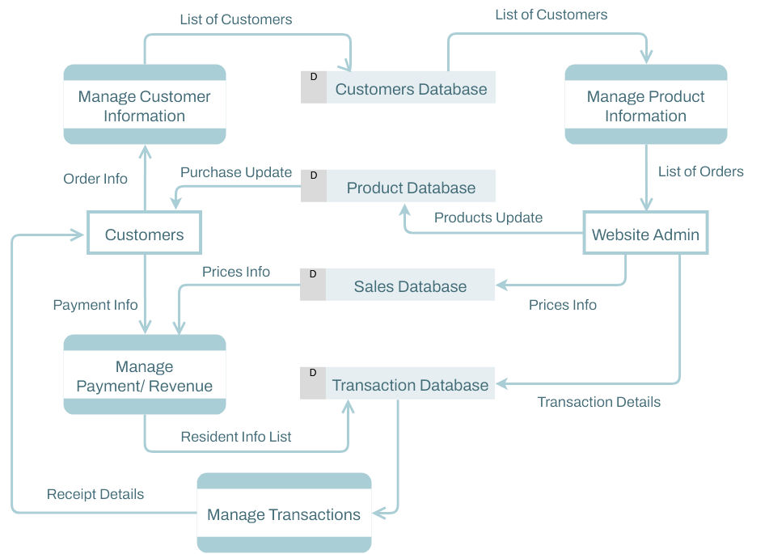

*Figure 3.1 Data Flow Diagram of Plantto*

1. Flowcharts:

Flowcharts diagrams will be employed to represent the system's processes.

Here is the flowchart for Plantto:

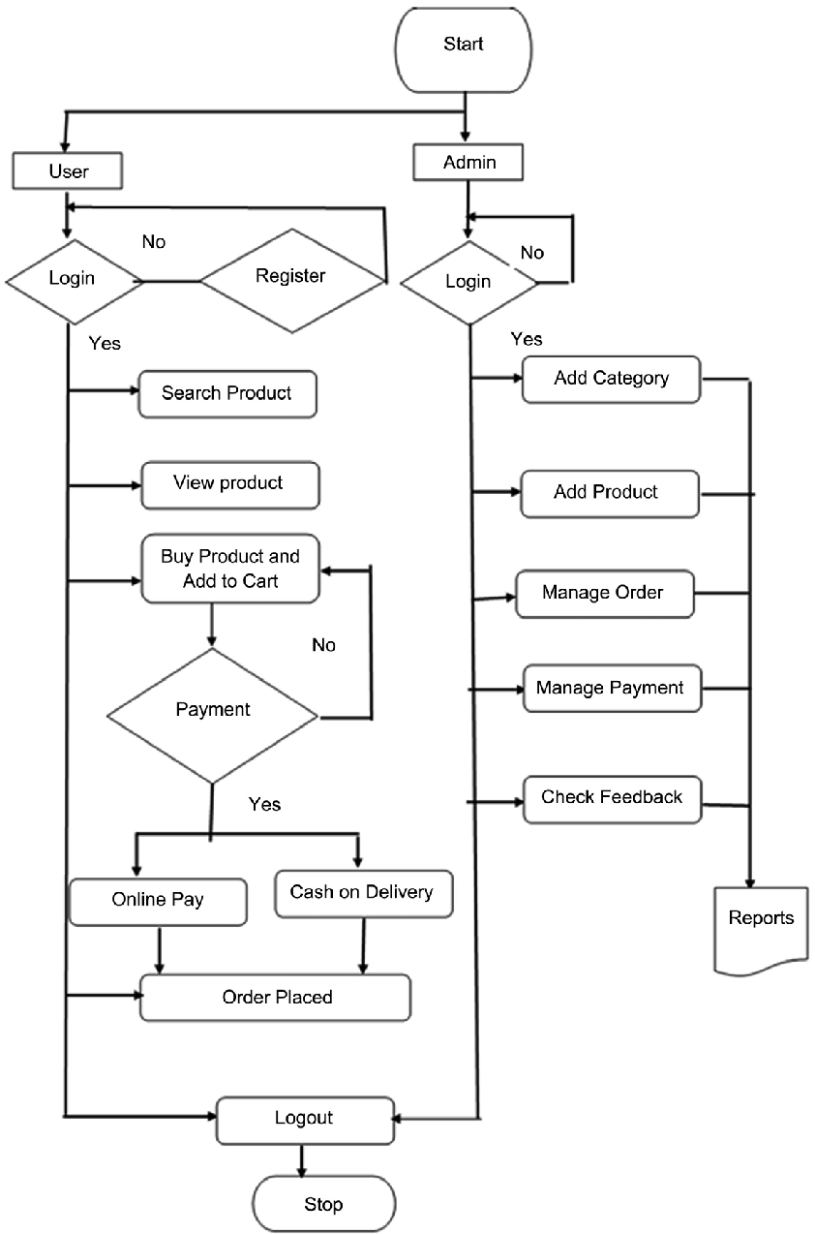

*Figure 3.2 Flowchart Diagram of Plantto*

**3.4 User Interface Design**

1. **Logo:**

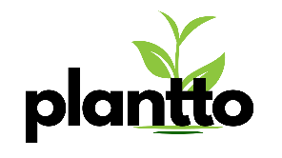

1. **Homepage:**



1. **Product Page:**

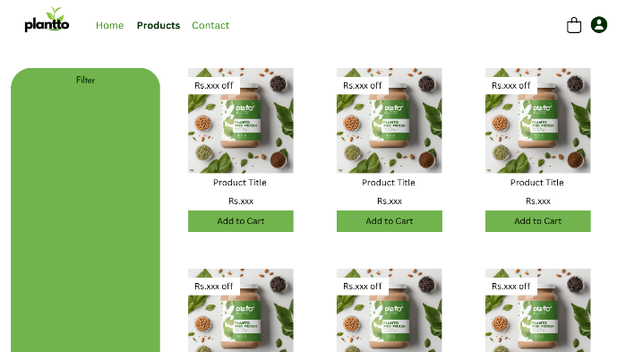

1. **Login & Sginup Page:**

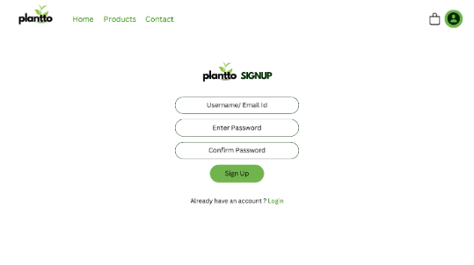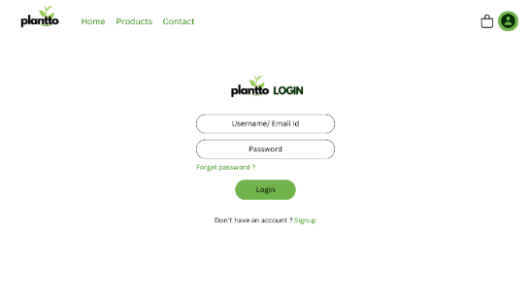

1. **Detail Product Page:**

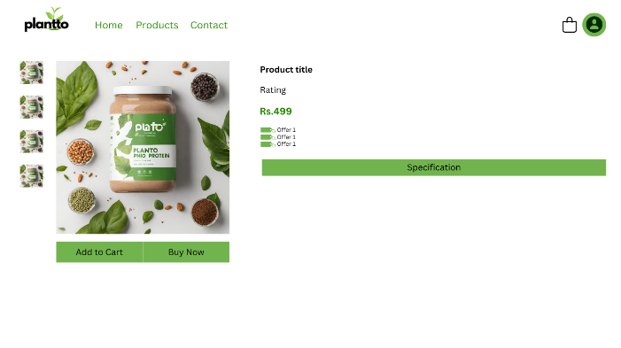

1. **Cart Page:**

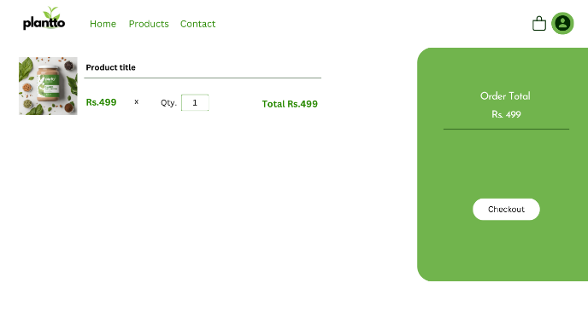

*Figure 3.3 Plantto UI Pages*

**3.5 Database Design**

**3.5.1 ER Diagrams**

Entity-Relationship (ER) diagrams will model the relationships between different entities in the database. Key entities include users, products, and orders.

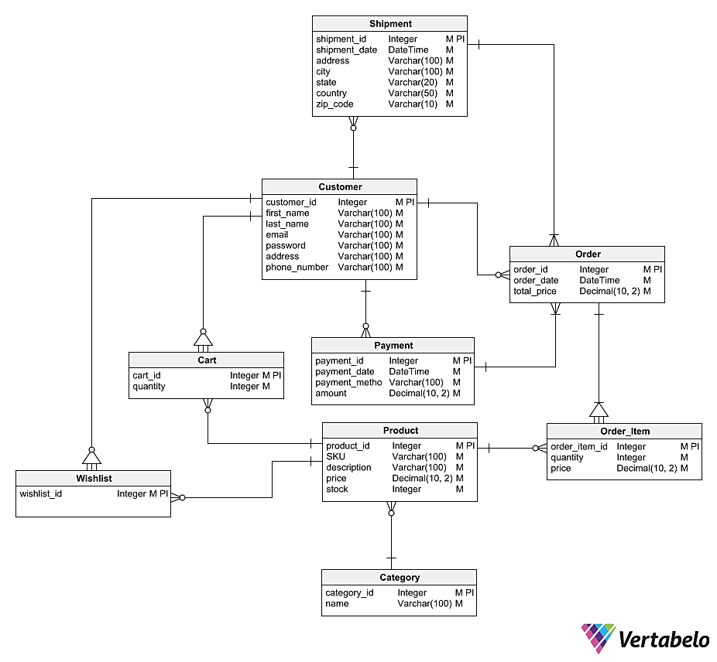

*Figure 3.4 Plantto’s ER Diagram*

**3.5.2 Database Manipulation**

SQLite (Structured Query Language) is used for database manipulation. This includes defining tables, inserting, updating, and retrieving data.

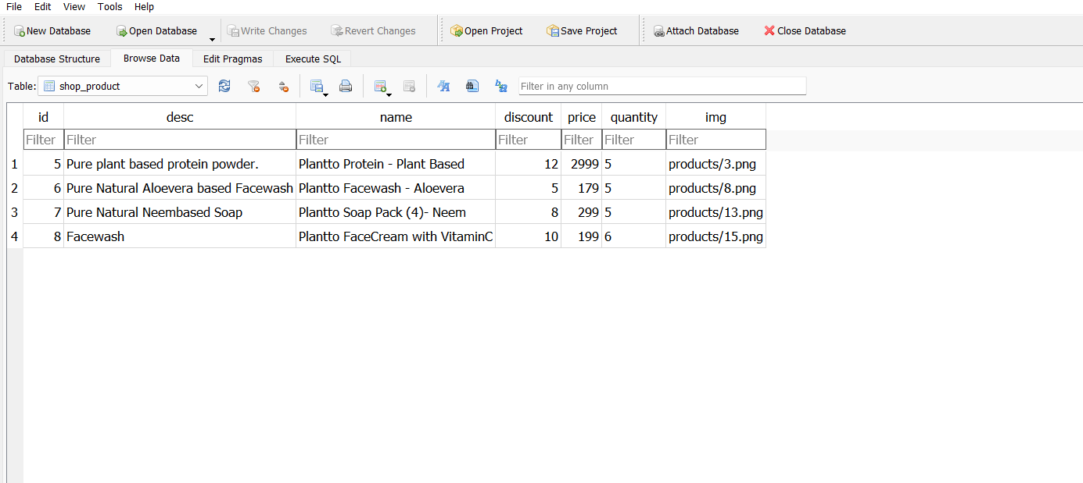

*Figure 3.5 Plantto’s Database*

**3.6 Methodology**

The methodology for system design will be based on an iterative and incremental approach. Each module will undergo rigorous testing, and feedback from testing phases will be used to refine and enhance the system. The Agile methodology will continue to guide the development process, ensuring adaptability to changing requirements and a responsive development cycle. Regular sprint reviews will involve stakeholders and end-users in the validation process, fostering collaboration and continuous improvement.

**Chapter 4: Implementation, Testing, and Maintenance**

**4.1 Introduction to Languages, IDE’s, Tools, and Technologies used for Implementation**

1. **Languages:**

* 1. **Python:** Used as the primary programming language for the backend logic.



[This Photo](https://communityblog.fedoraproject.org/help-port-python-packages-to-python-3/) by Unknown Author is licensed under [CC BY](https://creativecommons.org/licenses/by/3.0/)

* 1. **JavaScript:** Employed for frontend interactivity and user interface enhancements.



[This Photo](https://rsip22.github.io/portfolio/) by Unknown Author is licensed under [CC BY-SA](https://creativecommons.org/licenses/by-sa/3.0/)

* 1. **HTML and CSS:** Utilized for structuring and styling web pages.

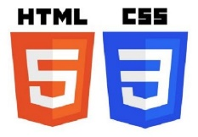

[This Photo](https://www.pedagogie.ac-aix-marseille.fr/jcms/c_10589494/fr/creation-de-pages-html/css) by Unknown Author is licensed under [CC BY-SA-NC](https://creativecommons.org/licenses/by-nc-sa/3.0/)

**2. IDEs and Tools:**

* 1. **Visual Studio Code:** As the primary integrated development environment (IDE) for coding and debugging.



* 1. **Django Framework:** A high-level Python web framework used for rapid development and clean, pragmatic design.



[This Photo](https://devopedia.org/django) by Unknown Author is licensed under [CC BY-SA](https://creativecommons.org/licenses/by-sa/3.0/)

* 1. **Bootstrap:** Frontend framework for designing responsive and visually appealing user interfaces.



[This Photo](https://getbootstrap.com/) by Unknown Author is licensed under [CC BY](https://creativecommons.org/licenses/by/3.0/)

*Figure 4.1 Used IDE & tool icons.*

**4.2 Coding Standards of Language Used**

The coding standards for Python and JavaScript adhere to PEP 8 and JavaScript Standard Style, respectively. Consistent indentation, naming conventions, and modular code structures are emphasized to enhance readability and maintainability.

**4.3 Project Scheduling using Various Tools**

Project scheduling is managed using Gantt charts in Visual Studio Code and other project management tools. Tasks are broken down into manageable units, and dependencies are identified. This visual representation aids in tracking progress and adjusting timelines as needed.

**4.4 Testing Techniques and Test Plans**

**4.4.1** **Testing Techniques:**

1. **Unit Testing:**
   1. Python Unit Testing: Leveraging the built-in `unit test` module to test individual units of code for correctness.
2. **Integration Testing:**
   1. Django Testing Framework: Ensuring the seamless integration of different components within the Django framework.
3. **System Testing:**
   1. End-to-End Testing: Conducting comprehensive tests to validate the system's functionality from the user's perspective.

**4.4.2 Test Plans:**

1. **User Authentication:**
   1. Verify the registration and login functionalities.
   2. Test password encryption and security measures.
2. **Product Listings and Shopping Cart:**
   1. Ensure accurate product listings and availability.
   2. Test the addition and removal of items from the shopping cart.
3. **Order Processing:**
   1. Confirm the correct processing of orders.
   2. Validate order confirmation and shipment tracking.
4. **Vendor Dashboard:**
   1. Test the vendor's ability to add, edit, and remove product listings.
   2. Verify inventory management functionalities.
5. **Community Features:**
   1. Test product reviews and ratings.
   2. Validate the functionality of discussion forums.
6. **Security Testing**:
   1. Conduct penetration testing to identify and fix potential vulnerabilities.
   2. Validate SSL implementation for secure data transmission.
7. **Performance Testing:**
   1. Assess the system's response time under various loads.
   2. Evaluate the scalability of the platform.

**4.5 Maintenance**

1. **Maintenance activities include:**
   1. **Bug Fixes:** Addressing and resolving reported issues promptly.
   2. **Updates and Enhancements**: Regularly updating the platform to add new features and improvements.
   3. **Security Patches:** Applying security updates to safeguard against potential threats.
   4. **User Support:** Providing ongoing support and addressing user queries.
   5. **Documentation:** Keeping documentation up-to-date for future reference and onboarding of new developers.

**Chapter 5: Results and Discussions**

**5.1 User Interface Representation**

**1. Homepage:**

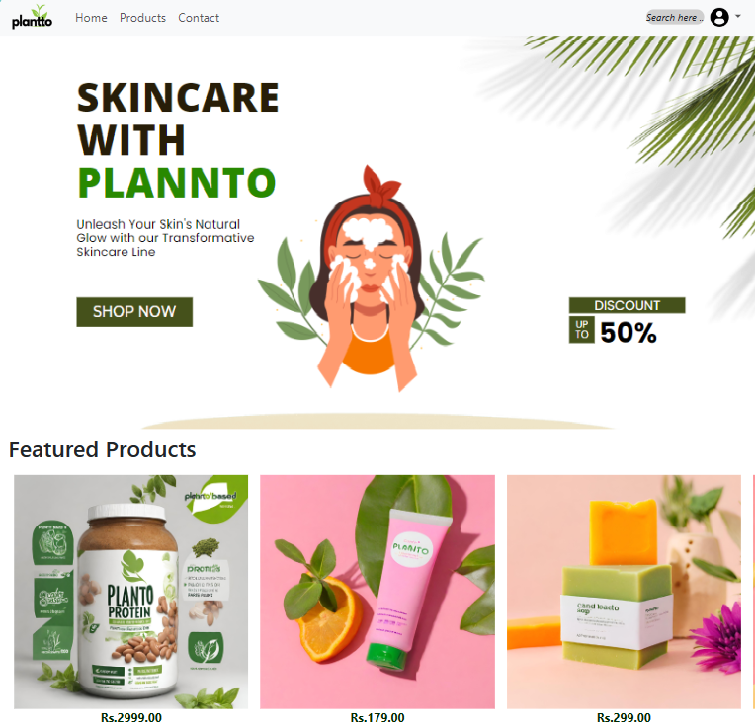

*Figure 5.1 Plantto’s Homepage*

**2. Product Listings:**

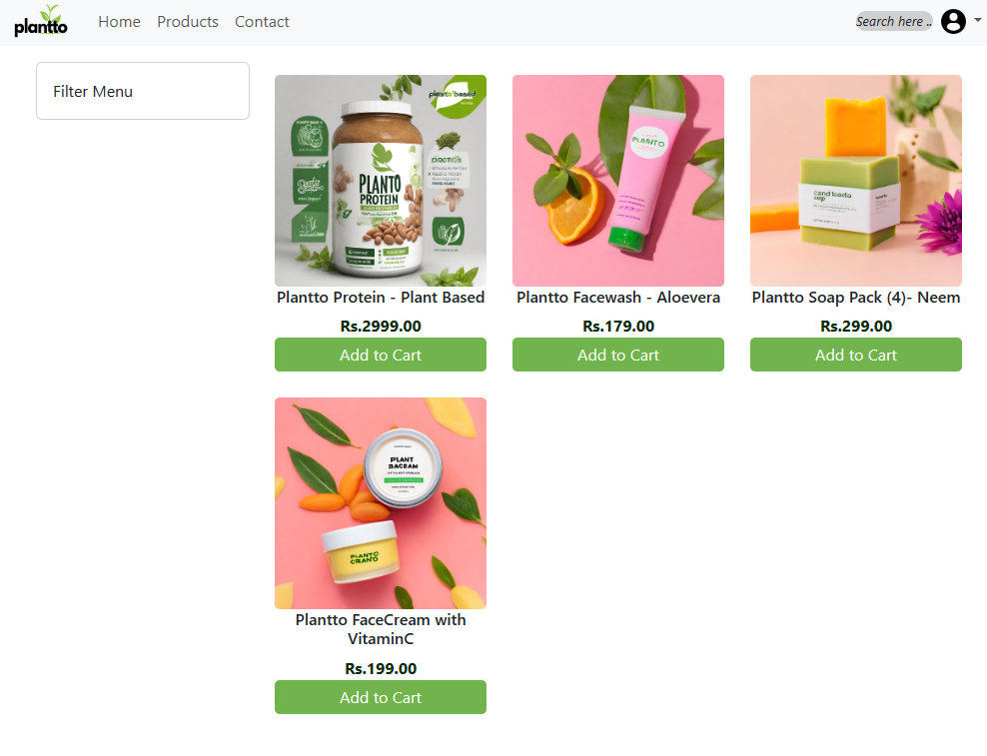

*Figure 5.2 Plantto Product Listing*

**3. User Authentication:**



*Figure 5.3 Plantto’s User Authentication.*

4. Shopping Cart:

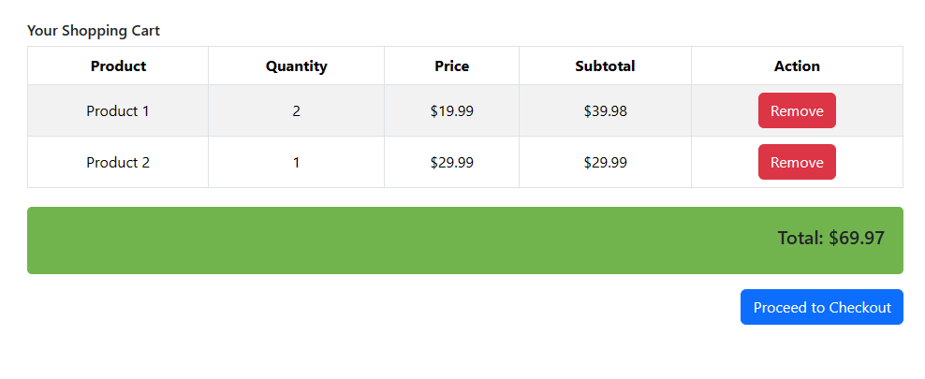

*Figure 5.4 Plantto’s Shopping Cart*

**5.3 Back Ends Representation**

**5.3.1 Snapshots of Database:**

**User Table**

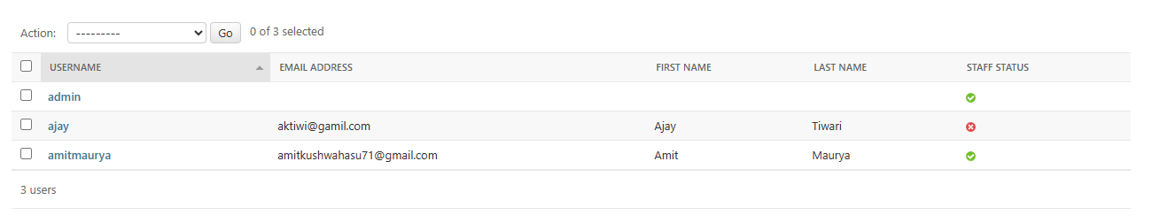

**Product Table**



*Figure 5.5 Plantto’s Backend Representation*

**5.4 Discussions**

The "Plantto" project successfully delivers a user-friendly e-commerce platform dedicated to plant-based products. The intuitive interface, efficient backend functionalities, and community engagement features contribute to a positive user experience. Ongoing maintenance and updates will focus on addressing user feedback, implementing enhancements, and ensuring the security and scalability of the platform. The discussions will continue to evolve based on user interactions and market trends, further solidifying "Plantto" as a leading platform for plant-based product enthusiasts.

**Chapter 6: Conclusion and Future Scope**

**6.1 Conclusion**

The development of the "Plantto" web-based e-commerce platform represents a significant achievement in the domain of plant-based product marketplaces. The project successfully addresses the need for a specialized platform, offering users a seamless and engaging experience. The user-friendly interface, robust backend functionalities, and community engagement features contribute to the overall success of the system.

The adoption of an Object-Oriented Design approach, coupled with the Agile Software Development Life Cycle, has allowed for efficient development, adaptation to changing requirements, and continuous improvement. The adherence to coding standards, thorough testing procedures, and systematic implementation have resulted in a reliable and scalable platform.

**6.2 Future Scope**

**6.2.1 Feature Enhancements**

**1. Personalized Recommendations**: Implement machine learning algorithms to provide personalized product recommendations based on user preferences and purchase history.

**2. Mobile Application Development:** Extend the platform's reach by developing dedicated mobile applications for both Android and iOS devices.

**3. Internationalization and Localization:** Enable support for multiple languages and currencies to cater to a global user base.

**6.2.2 Sustainability Metrics**

**1. Carbon Footprint Calculation:** Integrate tools to calculate and display the environmental impact of each product, providing users with sustainability metrics.

**2. Certification Badges:** Allow vendors to showcase certifications related to sustainability, organic sourcing, and cruelty-free practices.

**6.2.3 Blockchain Integration**

Explore the possibility of integrating blockchain technology to enhance the security and transparency of transactions and supply chain processes.

**6.2.4 Virtual Reality (VR) Shopping Experience**

Implement VR features to offer users an immersive and interactive shopping experience, allowing them to virtually explore products before making a purchase.

**References/Bibliography**

1. Pressman, R. S. (2014). Software Engineering: A Practitioner's Approach. McGraw-Hill Education.

2. Django Documentation. [<https://docs.djangoproject.com/>] (https://docs.djangoproject.com/)

3. Bootstrap Documentation. [<https://getbootstrap.com/docs/>] (https://getbootstrap.com/docs/)

4. Python Documentation. [<https://docs.python.org/>] (https://docs.python.org/)

5. Sommerville, I. (2011). Software Engineering (9th ed.). Addison-Wesley.